AuctiSafe: Building a Robust and Reliable Auction System for Optimized Security Measures

1st Wajiha Jawwad Ali  Dept. of Software Engineering  Iqra University Main Campus  Karachi, Pakistan  syeda.wajiha692@gmail.com | 2nd Abdul Qadir Abdul Latif  Dept. of Software Engineering, Iqra University Main Campus  Karachi, Pakistan  abdulqadir.aboobakar@gmail.com | 3rd Muhammad Yasir Mehboob Ali  Dept. of Software Engineering, Iqra University Main Campus  Karachi, Pakistan  yasirmehboob59@gmail.com |  | 4th Ibrar Ali  Dept. of Software Engineering,  Iqra University Main Campus  Karachi, Pakistan  99ibrarali@gmail.com
5th Mansoor Ebrahim  Dept. of Software Engineering  Iqra University Main Campus  Karachi, Pakistan  mebrahim@iqra.edu.pk |  |  | 6th Abdul Basit Abro  Dept. of Computer Science  Indus University  Karachi, Pakistan  abrobasit@gmail.com

Abstract—An online auction management system explores the complexities of auction organization and execution. This study investigates the intricacies of online auctions, focusing on the influence of different auction types and listing strategies on buyer behavior as well as the crucial role of fraud prevention. The study examined the effects of different types of online auction formats, including English Auctions, Dutch Auctions, and Reserved Price Auctions, on the duration of sales and the price achieved. Seller utilize various tactics, including pricing strategies and reputation management, to optimize their listings. Factors like item features also play a role in shaping their outcomes. In addition, our research sheds light on the ways in which online auction platforms avoid fraud. Among these techniques for effective reporting and resolution, method for secure payment processing, method for usage education, method for real-time monitoring, and methods for verifying identities. When all of these measures are in place, it creates an atmosphere that is free from fraud because it is open and honest. Finally, within the dynamic realm of electronic commerce, this study deepens our comprehension of online auctions, including topics such as seller tactics and fraud prevention.
Keywords— Fraud Prevention Methods, Transparent Environment, Safe Payment Processing, Real-time Monitoring

Introduction
With the help of an online auction management system, auctioneers can easily organize and run the entire sale, from beginning to end. Online auction platforms like Yahoo! Auctions and eBay have shown a rapid and significant increase in user engagement [1]. The quantity of auction commodities offered by eBay had a substantial surge, rising from hundred million in July 2010 to two hundred million in September 2014 [2-3].
An increase in participation and larger bid amounts is likely to result from the system's ability to facilitate remote bidding, which broadens the auction's reach and visibility. Incorporating knowledge and experience, we investigate the circumstances in which B2B auction purchasers will use the online-posted pricing channel, and we show that purchasers' preferences differ [4]. When it comes to logistical and physical limitations, online auctions have done away with proximity, preparation time, space, and a narrow target audience [5].
However, there are a lot of new opportunities for cheating in the digital age. Misrepresentation, promotion of illicit goods, and dishonesty are all examples of fraud that can happen before, during, or after an auction [6]. Another kind of fraud can happen when a bidder fails to pay for an item after the sale. The topic of much research has been the occurrence of fraud before and after auctions [7-8].
Modeling bidder behavior has been the primary focus of prior digital auction research [9–13]. This study has concentrated on topics such auction period, auction attributes, motivation to pay, competitive advantage, and format. the numbers. What drives consumers to bid on online auctions has received less empirical attention in the aforementioned literature. Advised further research, both empirical and theoretical, to clarify how online auction customers behave [14].
Value, size, and usability in the online marketplace have all increased at an exponential rate. In the years to come, this tendency is anticipated to pick up speed [15]. An integral part of the online marketplace, which makes use of e-commerce techniques, are online bidding mechanisms [16]. Everyone from auction organizers to vendors, bidders, purchasers, and logistics and shipping companies might end up using the system. The goal of the system is to keep user information secure, stop fraud, and keep the system up and running with little downtime.

Literature Review
In 1993, online auctions based on news groups were the first to appear on the web [17]. Online auction houses like eBay and On Sale were among the first to launch in 1995 [18]. The level of uncertainty experienced by online auction customers is higher compared to their in-person counterparts [19–20]. In order to sidestep the "lemons" problem, online auction houses have developed innovative ways for vendors to provide more details on their reliability and product quality [41]. With these updates and the buyer safety methods offered by other third-party payment auditors like PayPal, more people are interested in buying things through online auctions.
Online auction businesses are distinct from other types of e-Businesses in a number of ways. Let me start by saying that online auction platforms such as eBay are incredibly competitive markets. There are always a lot of similar things being sold by other merchants. Pages 21–22. A bigger online auction site organization (like eBay) is where online auction vendors are a member of. Because of this, sellers in online auctions are unable to set themselves apart from competitors. In addition, website trust, reputation, and quality can impact vendor pricing in online auctions, as purchasers set their own price limit. Lastly, customers may be misled into believing they are engaging with a trustworthy seller who possesses the required business expertise, such as shipping, when in reality they are not. The reason behind this is the ease with which an auction firm can be started and run using internet platforms. Lastly, a large number of digital auctions take place between strangers who have never met before, thus the confidence of the buyer or seller at the beginning of the process is crucial in determining the outcome.
Research into the usage of expensive qualitative indicators in digital auctions has been conducted. The application of reputation systems to supply vendors with pertinent past experience has been the focus of previous research. One way to keep track of people's opinions and assessments of their actions in the past is through a system for assessing reputation .The high cost of reputation system signals is a direct result of the time and effort required for vendors to prove their worth to a wide audience before they can claim to be a reliable market vendor. Online auctions also take into account the setting of a reserve price as a pricey quality indication.
Most auction companies' reputation systems are overly simplistic. Traders can only be rated on a ''adverse,'' ''unbiased,'' or ''beneficial'' scale after completing a deal. Some unscrupulous business owners and purchasers even resort to dishonest means to boost their image. Scammers might hide their true intentions from unsuspecting consumers by inflating their feedback scores through fabricated transaction records. Making a string of minor purchases to increase one's satisfactory status is another common method, followed by fraud on one large purchase. One more common sort of fraud when participating in auctions is using multiple states accounts. Initially, a con artist may choose aliases and use them to deceive others into thinking they are either themselves or their collaborators. The con artists then have their henchmen post positive evaluations to boost their own profiles.
The topological complexity and massive size of eBay make it amenable to modeling and analysis as a complex network. Auction models, approaches to purchasing and selling, models of credibility, and identification of deception are just a few of the areas that have examined eBay. Researchers significantly improved the detection rates of inflated accounts through the application of hierarchical evaluation, frauds involving inventory data—a collection of interrelated assets—can be discovered. A wide range of fraud and discrepancy detection tasks also benefit from this type of research. Finding outliers in complex social network features is possible with graph theory.
Making a list of the features of various approaches is the easiest method to build a quantifiable quality set for detecting fraud or swindles. Having a larger set of qualities does not, however, always lead to better categorization accuracy. Sifting through a huge pool of potential traits to identify the most relevant ones would be more efficient, even if it would seem reasonable to build a massive collection of all prospective attributes. A more direct translation of this would be that attribute selection is meant to speed up the generation of detection reports, which in turn improves cost-effect prognosis and aids in understanding the findings

Methodology

Data Description
We used a multimodal observational approach that included several sorts of auctions typically used in online marketplaces to conduct our complete study on eBay's multiple types of auctions and their impact on online purchasing behavior. From start to finish, each auction listing has thoroughly scrutinized, and our data collection concentrated on obtaining critical transaction-related data, price-related information, auction-specific characteristics, product-related traits, and seller-related facts. Given the variety of auction formats and their distinct dynamics, we included the following types of auctions in our research.
- Buy It Now (BIN) Auctions: Our major focus, where purchasers can purchase products immediately at a predetermined price or submit bids if the option is available.
- Dutch auctions are those in which the price begins maximum and gradually drops until a bidder accepts the current price as shown in Fig.1.
- English Auctions: The conventional ascending price auction in which participants submit rising bids until no one is ready to pay higher as shown in Fig.2.
- Reverse Auctions: Auctions in which buyers list their needs and sellers compete to give the best price in order to win the contract as shown in Fig.3.
- Forward Auctions: Auctions in which sellers offer products and purchasers bid to acquire the item at the lowest attainable price as shown in Fig.4.
- Reserve Auctions: Auctions having a concealed reserve price set by the vendor, with the item only being sold if the bidding meets or exceeds this minimal barrier as shown in Fig.5.
- Sealed Bid Auctions: These auctions are frequently used in government and company procurement processes. Participants submit anonymous bids and the highest bidder wins.as shown in Fig.6.
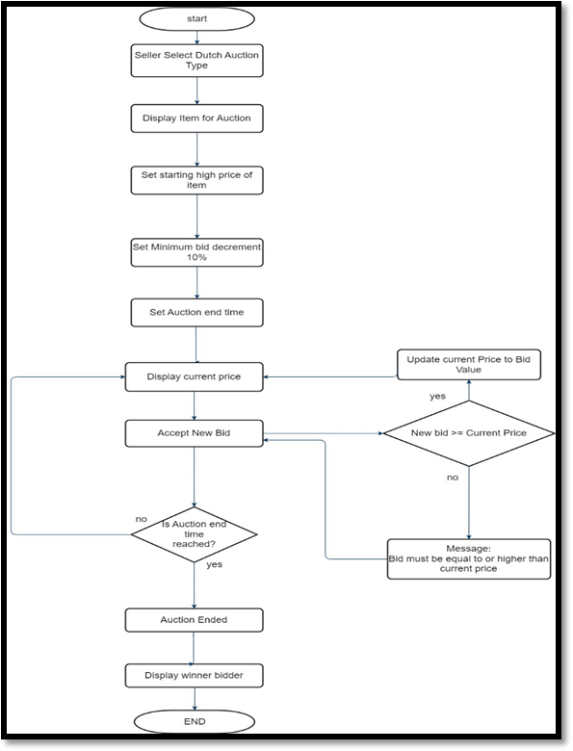
- Dutch Auction Type Flowchart
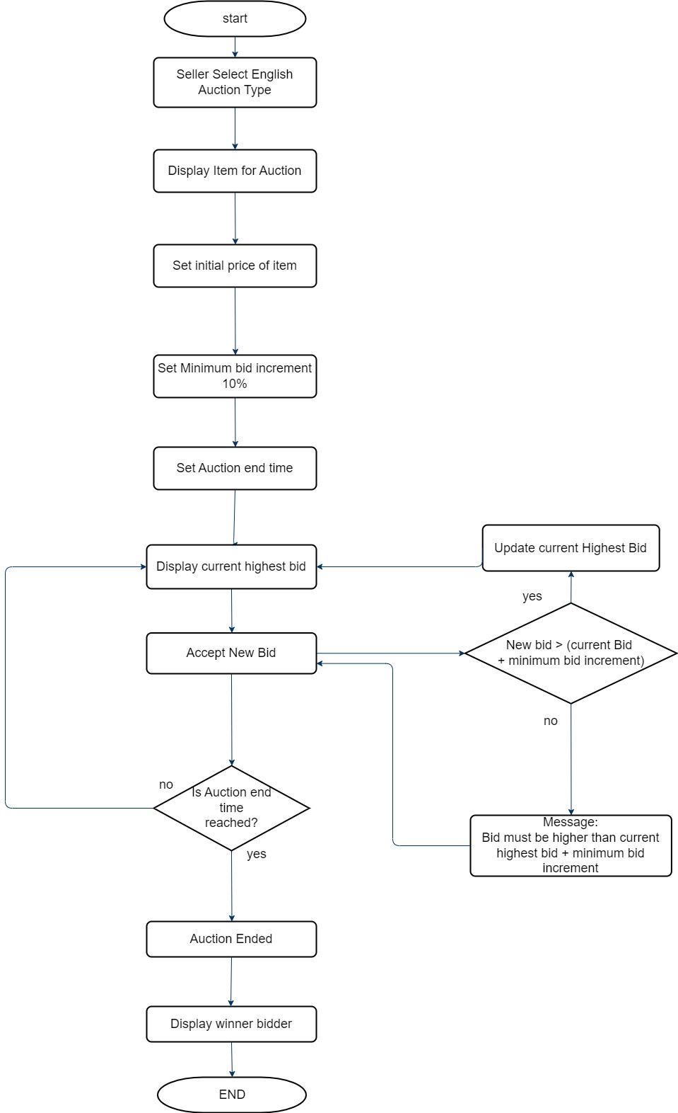
- English Auction Type Flowchart
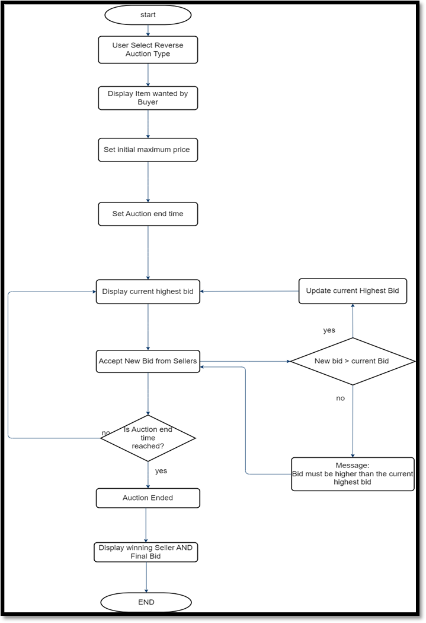
- Reverse Auction Type Flowchart
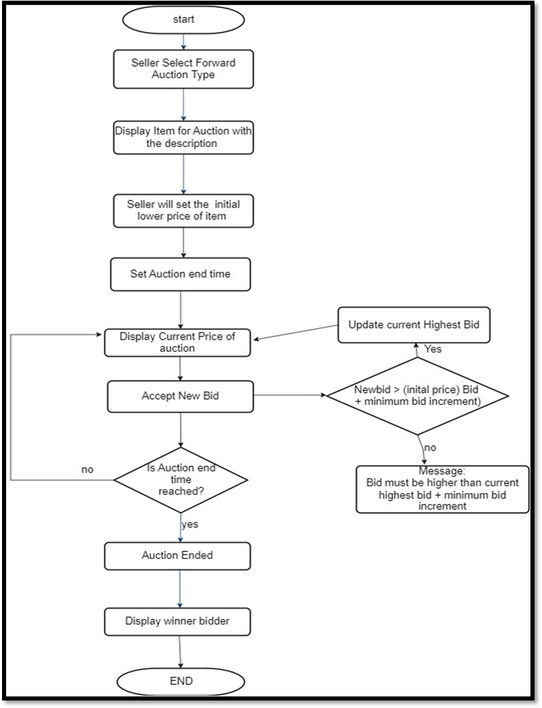
- Forward Auction Type Flowchart
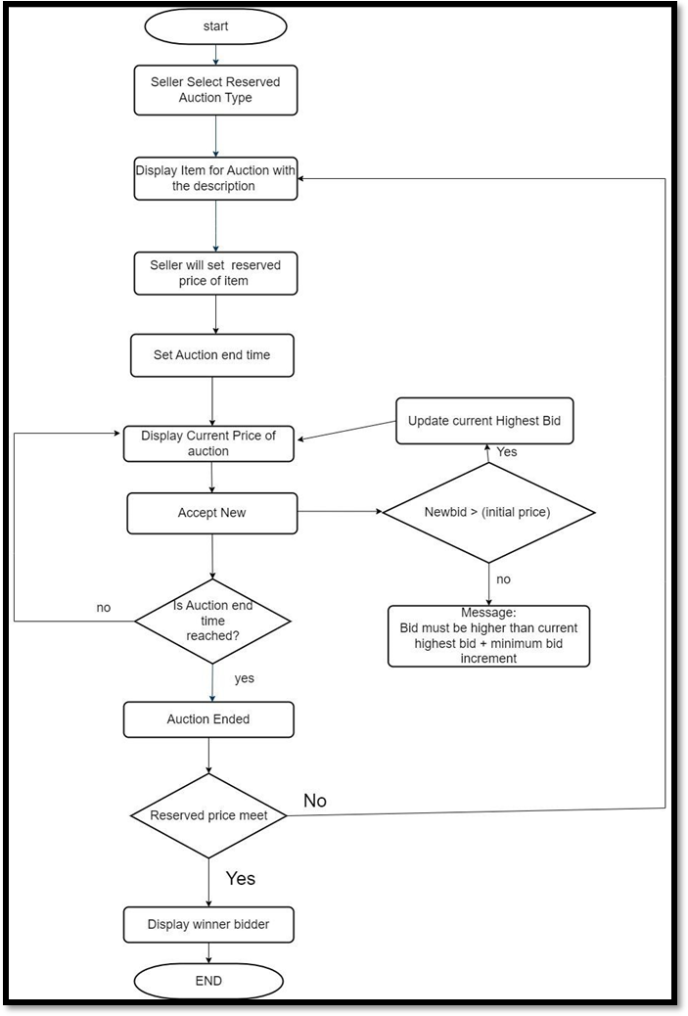
- Reserved Auction Type Flowchart
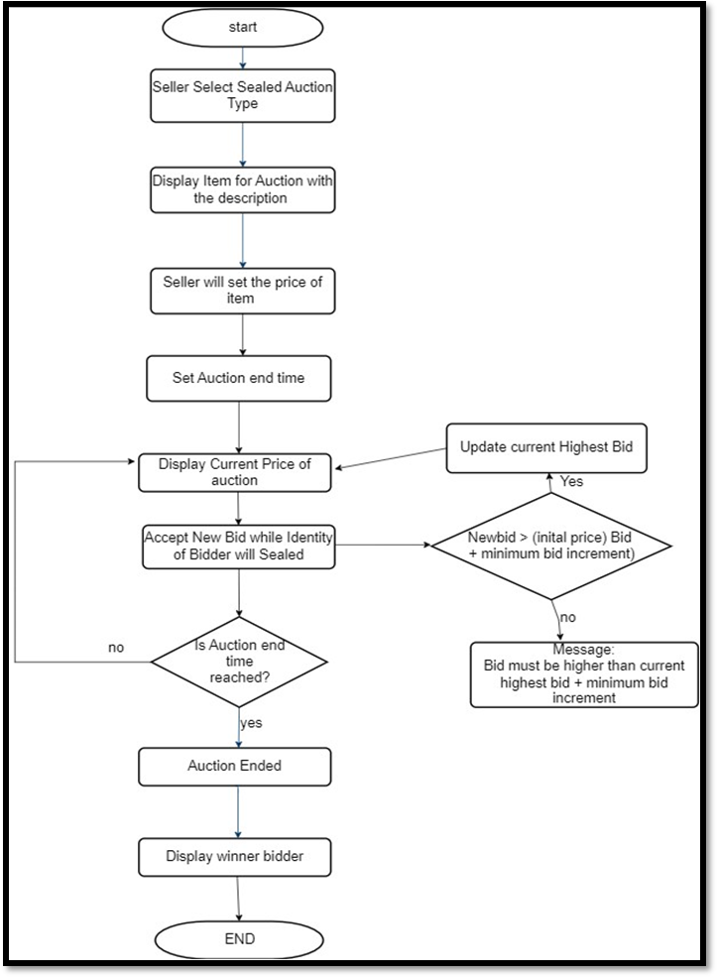
- Sealed Bid Auction Type Flowchart

Listing Strategies for Sellers
- Listing type Selection: Vendors give much thought to which listing type is most suitable for their products. The decision to employ Regular Auctions (RA), Auctions with Buy It Now (ABIN), or Fixed-Price (FP) listings is based on their evaluation of the item's marketability, demand, and perceived worth. FP gives a set selling price, ABIN gives fast purchasing options, and RA could prompt competitive bidding.
- Setting the First Starting Price: Sellers meticulously determine the bottom price at which their listings begin. This choice has influenced by their estimation of the item's worth, current market circumstances, and their aim to stimulate early bidding. Competitive bidding and a higher final sale price are both result of a well-chosen beginning price.
- Buy It Now (BIN) Price Strategy: When creating an price for ABIN listings, sellers deliberately choose the Buy It Now (BIN) price. The best-in-market (BIN) price indicates the seller's assessment of the item's worth and their desire to move it quickly. To optimize profitability and simultaneously attract rapid sales, dealers will modify these prices.
- Listing Duration: Sellers get to decide how long their listings will be up for grabs. Buyer behavior may be influenced by the length of the duration, since it gives potential buyers more time to explore the item and place bids. Reduced time frames have the potential to increase bidding by creating a feeling of urgency.
- Setting Secret Reserve Price: Some vendors set an invisible minimum price that must be satisfied before the item may be sold. This is called a secret reserve price. This strategic tool protects against selling an item for less than a predetermined threshold, ensuring the seller's minimum price is met while still allowing competitive bidding.

Model Architecture
AuctiSafe's architectural framework is a sophisticated online auction platform developed to provide seamless and secure bidding experiences and involves the use of multiple layers. As Indicated in fig.7, AuctiSafe has designed to control the flow of operations caused by HTTP requests from the User Interface (UI) layer as effectively as possible.
- User Interface (UI) Layer: Here, users communicate with the platform using HTTP requests.
- Application Server: The application server module is in charge of handling requests and enabling communication between other modules.
- Authentication and Authorization: It ensures secure access by checking the user's credentials.
- Auction Management: The creation and scheduling of auctions, together with the determination of their criteria and timing, are all aspects of auction management.
- Bid Management: Records and processes bids, monitors compliance with auction rules, etc.
- Payment Processing: Manages monetary transactions by communicating with payment gateways in a secure manner.
- Notification Services: Auction updates, winning bids, payments, and other events are communicated to users via email and other channels through the notification service.
- Database Layer: The database layer stores and retrieves information about users, items, auctions, and reports, ensuring that the data remains intact.
- Automated Workflow: To avoid fraud, the AuctiSafe design has an automated workflow that checks the UI layer's HTTP requests for successful processing. This automation, the auction process is now more streamlined, consistent, and easy to use.
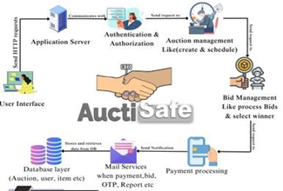
- Model Architecture of AuctiSafe

RESULTS
Critical insights into the complicated dynamics of online auctions are revealed by our research of eBay auction data and literature reviews. These findings cover a wide spectrum, from the impact of fraud protection strategies to the impact of sellers' listing approaches on auction results. Important factors that determine the results of auctions include Regular Auctions (RA), also known as English auctions, Auctions with Buy It Now (ABIN), also known as Dutch auctions, or Sealed-Bid auctions. Listings with RA make bidding more competitive, listings with ABIN make sales more rapid, and listings with FP2 make prices more stable.
Variables like beginning prices and BIN prices (ABIN) are used by sellers to optimize listings. Also influencing listing strategies are item characteristics, seller reputation, and feedback ratings. Identity verification, safe payment processing, user education, real-time monitoring, and quick reporting and resolution are some of the successful fraud protection processes highlighted by our research. By working together, we strengthen the platform and provide users with an online auction experience that is safe, clear, and free of fraud.

References

- Majadi, N., Trevathan, J., & Bergmann, N. (2016, August). uAuction: Analysis, design, and implementation of a secure online auction system. In 2016 IEEE 14th Intl Conf on Dependable, Autonomic and Secure Computing, 14th Intl Conf on Pervasive Intelligence and Computing, 2nd Intl Conf on Big Data Intelligence and Computing and Cyber Science and Technology Congress (DASC/PiCom/DataCom/CyberSciTech) (pp. 278-285). IEEE.
- Truong, M., Gupta, A., Ketter, W., & van Heck, E. (2022). Buyers’ strategic behavior in B2B multichannel auction markets: When an online posted price channel is incorporated into a Dutch auction system. Information Systems Research, 33(4), 1344-1367.
- Majadi, N., Trevathan, J., & Bergmann, N. (2016, August). uAuction: Analysis, design, and implementation of a secure online auction system. In 2016 IEEE 14th Intl Conf on Dependable, Autonomic and Secure Computing, 14th Intl Conf on Pervasive Intelligence and Computing, 2nd Intl Conf on Big Data Intelligence and Computing and Cyber Science and Technology Congress (DASC/PiCom/DataCom/CyberSciTech) (pp. 278-285). IEEE.
- Tsvetovat, M., & Sycara, K. (2000, June). Customer coalitions in the electronic marketplace. In Proceedings of the fourth international conference on Autonomous agents (pp. 263-264).
- Jin, Y., & Lu, P. (2023). First Price Auction is 1-1/e 2 Efficient. Journal of the ACM, 70(5), 1-86.
- Sogn-Grundvåg, G., & Zhang, D. (2023). Auction versus direct sale: the effect of buyers and sellers on prices. European Review of Agricultural Economics, 50(1), 84-114.
- He, W., & Li, J. (2022). Correlation-robust auction design. Journal of Economic Theory, 200, 105403.
- Dordunoo, C. K. (2020). The foreign exchange market and the Dutch auction system in Ghana (Doctoral dissertation, AERC).
- Abro, A. A., Siddique, W. A., Talpur, M. S. H., Jumani, A. K., & Yaşar, E. (2023). A combined approach of base and meta learners for hybrid system. Turkish Journal of Engineering, 7(1), 25-32.
- Wu, S., Chen, Y., Wang, Q., Li, M., Wang, C., & Luo, X. (2018). CReam: A smart contract enabled collusion-resistant e-auction. IEEE Transactions on Information Forensics and Security, 14(7), 1687-1701.
- Wu, S., Chen, Y., Wang, Q., Li, M., Wang, C., & Luo, X. (2018). CReam: A smart contract enabled collusion-resistant e-auction. IEEE Transactions on Information Forensics and Security, 14(7), 1687-1701.
- Li, S., Srinivasan, K., & Sun, B. (2009). Internet auction features as quality signals. Journal of Marketing, 73(1), 75-92.
- Dong, F., & Xu, S. M. (2008). Combating Online In-Auction Fraud: Clues. Techniques and Challenges.
- Dong, F., Shatz, S. M., & Xu, H. (2009). Combating online in-auction fraud: Clues, techniques and challenges. Computer Science Review, 3(4), 245-258.
- Khan, A. A., Laghari, A. A., Kumar, A., Shaikh, Z. A., Baig, U., & Abro, A. A. (2023). Cloud forensics-enabled chain of custody: a novel and secure modular architecture using Blockchain Hyperledger Sawtooth. International Journal of Electronic Security and Digital Forensics, 15(4), 413-423.
- ABRO, A. A., TALPUR, M. S. H., & JUMANİ, A. K. (2023). Natural Language Processing Challenges and Issues: A Literature Review. Gazi University Journal of Science, 1-1.
- Abro, A. A., Siddique, W. A., Talpur, M. S. H., Jumani, A. K., & Yaşar, E. (2023). A combined approach of base and meta learners for hybrid system. Turkish Journal of Engineering, 7(1), 25-32.
- Adesola, F., Odun-Ayo, I., & Emetere, M. THE DESIGN AND IMPLEMENTATION OF A SECURE ONLINE SEALED-BID AUCTION SYSTEM.
- Bag, S., Hao, F., Shahandashti, S. F., & Ray, I. G. (2019). SEAL: Sealed-bid auction without auctioneers. IEEE Transactions on Information Forensics and Security, 15, 2042-2052.
- Kulpa, J., Olczak, P., Surma, T., & Matuszewska, D. (2021). Comparison of support programs for the development of photovoltaics in Poland: My Electricity Program and the RES Auction System. Energies, 15(1), 121.
- Aldaej, R., Alfowzan, L., Alhashem, R., Alsmadi, M., Almarashdeh, I., Alshabanah, M., ... & Tayfour, M. F. (2018). Analyzing, Designing and Implementing a Web-Based Auction online System. ALDAEJ, R., ALFOWZAN, L., ALHASHEM, R., ALSMADI, MK, AL-MARASHDEH, I., BADAWI, UA, ALSHABANAH, M., ALRAJHI, D. & TAYFOUR, M, 8005-8013.

Auction with Buy It Now

